|  |  |
| --- | --- |
| *www.IowaABD.com* | *Lynn M. Walding, Administrator* |

|  |  |
| --- | --- |
|  | e - NEWS |
| *August 13, 2004* | |

1. Wall St. Might Soon Order Bacardi & IPO

2. Impact of Drinking Law Seems Slight

3. Another Round for the Drinks Sector

4. Coors Wins GOP Senate Primary in Colorado

5. U.S. Government Reports Significant Decline in Drunk Driving Fatalities

6. Diageo's Unwarranted Pounding

**1.** Wall St. Might Soon Order Bacardi & IPO

*Associated Press*

August 6, 2004

Simply ordering a 'vodka tonic' at your local drinking establishment might be met with a perplexed gaze from the bartender and a question: what kind?

More and more Americans - from urban hipsters at posh lounges to clock-punchers hitting a happy hour - are asking for their libations by brand name alone. And that suits Bacardi Ltd. chairman Ruben Rodriguez just fine.

The closely held spirits giant just completed its takeover of vodka maker Grey Goose in a deal estimated at close to $2 billion. The acquisition adds to a well-known portfolio of brand names recognized globally, including Dewar's Scotch whiskey, Cazadores tequila, Martini & Rossi vermouth, Bombay gin, and the venerable Bacardi rum.

Rodriguez, the first executive to lead the company not related to the Bacardi family, also hopes Wall Street investors call their drinks by brand name. Analysts think the addition of Grey Goose to the zinger of a mix might boost the cachet enough to persuade the Bacardi family to pursue a much-talked about initial public offering.

"Everyone asks me this," said Rodriguez, 67, during a phone interview on Friday from the company's headquarters in Hamilton, Bermuda. "If there's an acquisition that comes along that would be so big it would require a public offering - and as long as the use of the proceeds would improve our rate of return - we would consider it."

The company's thirst for acquisitions has been apparent since it bought Martini & Rossi in 1993, followed five years later by picking up the Dewar's and Bombay brands from Britain's Diageo Plc. But the major deal that would practically transform the company overnight has proven to be elusive.

In 2001, Bacardi joined Brown-Forman Corp. - the Louisville, Kentucky-based maker of Jack Daniel's - in an unsuccessful bid for Seagram Co.'s liquor business. Beating them to the punch was Diageo and France's Pernod Ricard SA, the second- and third-largest liquor companies in the world.

"They definitely want to expand, take advantage of their worldwide reach, and move towards that IPO," said Peter Cressy, chief executive of the Distilled Spirits Councils of the United States, an industry trade organization. More importantly, he believes it gives Bacardi a much-coveted name that will attract customers and investors alike.

"They want people to go in and order a Bombay and tonic or a Grey Goose cosmo...these days its all about the name," he said. "They know exactly what they're doing, and this kind of portfolio makes them a real force in the industry."

Bacardi is the world's largest privately held spirits company and ranks fourth among those that trade publicly. The company sells more than 350 million bottles per year in 170 countries, with profits last year more than $300 million.

The company has been slowly paving the way for a possible public offering since a flotation failed to get off the ground in 2000. Two years ago, Bacardi created two classes of private shares to make a possible IPO more advantageous for its 600 shareholders - of which 98 percent are family members.

Earlier this year, shareholders approved a plan in which the company is free to sell more shares in a public or private offering as a way to finance future acquisitions. An IPO, which some analysts say could fetch upward of $7 billion, would be a big step for a company controlled by the same family since it was founded in Cuba in 1862.

What would make Bacardi of interest to Wall Street is its vast holdings of brand name products, most of which would read like a roll-call of bottles on a bar's top shelf. Adding Grey Goose - which commands 3.4 percent of the U.S. vodka market with some 1.4 million cases sold last year - bring even more luster to a firm primarily known as the world's biggest rum maker.

"This would goose up Bacardi's growth and profits, making shares more attractive," said Banc of America analyst Bryan Spillane.

The so-called "super-premium" vodka, which includes brands such as Absolut, Vox, and Ketel One, has become one of the biggest sellers in the U.S. market, according to the Distilled Spirits Council. The cost of these top-tier vodkas runs about $30 a bottle.

Vodka accounts for the largest sales of liquor over all in the U.S., with shipments of 41.9 million cases last year alone. Picking up Grey Goose gives Bacardi more than half of the U.S. super-premium market, according to numbers provided by the Distilled Spirits Council.

This also gives Bacardi the brand name it has been searching for after its first foray into vodka sales failed to make a splash with the 2002 introduction of the Turi brand, a small player in the super-premium market.

"From a strategy point of view, we want to make Bacardi Ltd. a very big player in the industry, and that's very important to us," Rodriguez said. "Bacardi rum is our flagship, but we've remained very interested in acquiring a brand that has a name and caliber to it, like Grey Goose."

Rodriguez ruled out expanding beyond spirits, like rival Diageo has done. Even beer and wine is not a likely target because he said the company intends to "stick with what we know."

While an IPO might be in the cards for Bacardi, Rodriguez ruled out questions that the family has any interest in becoming a takeover target itself. There's no interest in entertaining bids from rivals, he said.

"We were pretty much pioneers in the drink segment, and have been successful with it," he said. "And the Bacardi name carries a mystique to it and hope that the family will continue to control this business forever and ever."



**2. Impact of Drinking Law Seems Slight**

By Lynn Campbell – *Des Moines Register*

August 8, 2004

But traffic deaths are down, first arrests are up, and some Iowans appear to be more aware of their intake.

DES MOINES, IA -- Iowa's year-old stricter standard for drunken driving has meant fewer traffic deaths, more first-time arrests, and more Iowans becoming conscientious when they drink alcohol.

"We take a lot more cabs than we used to," said Lindsey Edwards , 27, of Des Moines, who recently stopped for a drink at Wellman's Pub on Ingersoll Avenue. "We don't drink like we used to. I had a friend who got caught last year."

However, the law apparently has had little impact on bar sales, court caseloads and jail capacities.

"We haven't seen much of an impact in terms of volume of sales," said Suzanne Summy , general manager of Greenbriar Restaurant & Bar in Johnston. "I do see people much more aware. I hear a lot more conversation about that than I've ever heard before. There are consequences."

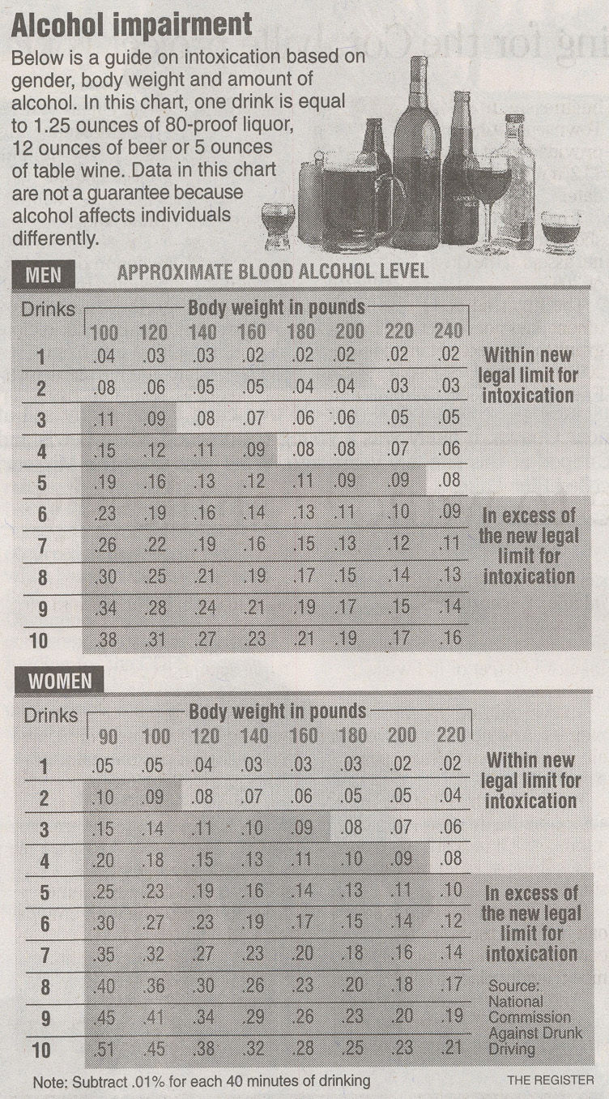

On July 1, 2003, Iowa lowered the legal blood-alcohol limit for drivers from .10 to .08, as required by federal law. The difference amounts to about one less drink per hour to be considered drunk in the eyes of the law.

That's more than four drinks in an hour for a 170-pound man on an empty stomach. It's about three drinks in a hour for a 137-pound woman, although those are averages and the effects of alcohol can vary, depending on the person.

Last month, .08 became the legal limit in all 50 states, the District of Columbia and Puerto Rico. The last state to enact the law was Delaware. While conclusive data on the effects of the change are not yet available, early numbers show:

Crashes: Alcohol-related crashes in Iowa were down 19 percent - from 69 between July and December 2002, to 56 in the second half of 2003. Deaths as a result of those crashes were down 15 percent, from 74 to 63 , said Scott Falb, a driver's safety specialist for the Iowa Department of Transportation.

"It's certainly a measurable and a fairly significant decline," said Bob Thompson, program evaluator for the Governor's Traffic Safety Bureau. "It's probably more than coincidence that that happened."

Numbers for 2004 are not yet available. However, officials predict that alcohol-related deaths have also decreased this year because overall traffic deaths are down 21 percent. There were 205 fatalities as of Friday, down from 260 on the same day last year.

Arrests: The Iowa State Patrol arrested 111 people with blood-alcohol levels between .08 and .10 over the past fiscal year, said Lt. Shane Antle.

That's about 4 percent of drunken-driving arrests made by troopers in the past year. The State Patrol's arrests generally represent about 15 percent to 20 percent of total drunken-driving arrests around the state, officials said.

Most Iowa counties do not keep separate statistics on those arrested because of the new legal limit. However, a December survey by the Iowa County Attorneys Association showed Iowa had a 5 percent increase in drunken-driving arrests and 9 percent increase in first-time violators statewide in the first four months of the law. That survey has not been updated.

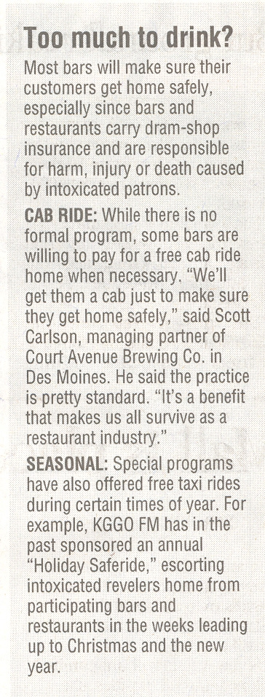

In Polk County, about 51 people were arrested with blood alcohol levels between .08 and .10 over the past year - an average of about four arrests a month. Dubuque County had 48 such arrests since July 2003. And Black Hawk County arrested 42 people whose blood-alcohol was between .08 and .10. Officials said most of those arrested were first-time offenders.

"I think there was a large concern that we'd be inundated by increases in the number of OWI arrests," said Black Hawk County Attorney Thomas Ferguson. "The numbers just really don't bear that out. We have not been dramatically affected in terms of personnel and court time because of these cases."

While numbers weren't available for all of Linn County, Sheriff Donald Zeller said his department alone made 78 arrests of people with blood alcohol levels between .08 and .10 over the past year.

Driver's licenses: Fewer people had their driver's licenses taken away last year because of drunken-driving arrests. There were 8,463 revocations in the second half of 2003, down from 8,816 the previous year, according to the Iowa Department of Trans portation.

"With all of the media attention to .08 legislation as it was working through the Legislature, it may be that people were being more conscious of it and changing their drinking habits to kind of fall in line," Falb said.

Officials could not explain why fewer licenses were being taken away when the number of drunken-driving arrests appeared to be increasing. However, Iowa's new law made it easier for some people to drive again after a drunken-driving arrest.

Today, first-time offenders immediately qualify for a permit to drive to work after they are arrested, as long as they were not responsible for an accident causing personal injury or property damage. It used to be that first-time offenders had their licenses suspended for at least 30 days regardless of the circumstances.

Alcohol sales: Information on the impact of .08 on alcohol sales is mainly anecdotal. There are mixed reviews on whether it has hampered bar sales, but it doesn't appear to have closed any bars.

Tom Duax, owner of Central City Liquor in Des Moines, a wholesaler-retailer that sells liquor to more than 100 bars and restaurants, said the new law hasn't decreased his sales. "It's really not been an issue with me at all," he said. "I don't think I've had many bars mention it."

Summy, of the Greenbriar restaurant in Johnston, agrees there's been little change among her customers, except for some who are ordering a half-bottle of wine instead of a full bottle. "I don't see a change in their drinking habits," she said. "I just see a change in who's going to be responsible tonight. They just keep on consuming."

But Eric Skoog, owner of Cronk's Cafe Restaurant and Lounge in Denison, estimated he has seen a 10 percent to 12 percent drop in sales of alcoholic beverages. "On the bar, we definitely see it," he said. "People are definitely more conscious of it."

Darin Beck, president of the Barmuda Corp . in Cedar Valley, which has two nightclubs, two restaurants, a pizza store with a bar, a lounge and a sports bar, said people are having more home parties and drinking closer to home.

"I think we've seen somewhat of a decrease in people drinking when they go out," he said. "The amount that people consume has certainly gone down. People tend to stay away from where police might be. People are just a lot more aware of the risk."

One thing's clear: Iowans haven't stopped drinking.

Lynn Walding, administrator of the state Alcoholic Beverages Division, said liquor sales in the past fiscal year increased just more than 10 percent over the previous year.



**3. Another Round for the Drinks Sector**

By Neil Hume – *The Guardian*

August 12, 2004

The ability to rehash an old story as a fresh, exciting tip is a skill that every broker needs, particularly in the quiet summer months when trading volumes, and therefore commissions, start to dry up.

Against that backdrop, a couple of recent favourites were dusted down and given another airing yesterday.

The first was talk of a bid approach for the Beefeater gin maker **Allied Domecq**, up 7.25p at 437.25p, from either Pernod Ricard or Bacardi. This tale has done the rounds many times before but it does have a certain logic in as much as a merger of Allied and Bacardi, for example, would create a company better equipped to take on market leader **Diageo**, off 2p at 664p.

Sector watchers reckoned the rise had more to do with the bargain hunting - Allied shares have fallen 10% in the past month and this week hit their lowest level since February - and an upgrade from Cazenove, one of its two house brokers.

Lifting his recommendation from in-line to outperform, Cazenove analyst Sandy Soames said the shares, which trade on 11.5 times 2005 earnings, were now back in buying territory.

He also said Allied was likely to quash concerns that the trading had slowed, by issuing a bullish trading statement early next month.



**4. Coors Wins GOP Senate Primary in Colorado**

Majette wins Democratic runoff in Georgia

|  |  |
| --- | --- |
| http://i.cnn.net/cnn/images/1.gif | vert.coors.majette.ap.jpg  **Senate race primary winners: Peter Coors in Colorado, Denise Majette in Georgia** |
| http://i.cnn.net/cnn/images/1.gif |  |
| http://i.cnn.net/cnn/images/1.gif |  |

(AP) -- Brewery heir Peter Coors won a bruising Republican primary for Colorado's open Senate seat Tuesday, beating a conservative former congressman to set up a high-stakes showdown with the Democratic attorney general this fall.

In Georgia, first-term Rep. [Denise Majette](javascript:CNN_openPopup('/ELECTION/2004/special/senate/interactive/whos.up/frameset.ga.exclude.html','620x430','toolbar=no,location=no,directories=no,status=no,menubar=no,scrollbars=no,resizable=no,width=620,height=430')) crushed a millionaire businessman to win a Democratic runoff for the seat being vacated by retiring Georgia Sen. Zell Miller. She became the first black candidate ever nominated to the U.S. Senate in Georgia.

With 85 percent of precincts reporting, [Coors](javascript:CNN_openPopup('/ELECTION/2004/special/senate/interactive/whos.up/frameset.co.exclude.html','620x430','toolbar=no,location=no,directories=no,status=no,menubar=no,scrollbars=no,resizable=no,width=620,height=430')) had 170,581 votes, or 61 percent, and former Rep. Bob Schaffer had 110,692 votes, or 39 percent. On the Democratic side, Attorney General Ken Salazar had 144,953 votes, or 73 percent, and educator Mike Miles had 52,362 votes, or 27 percent.

The winner in November will take the seat currently held by retiring GOP Sen. Ben Nighthorse Campbell.

Democrats believe the race represents a golden opportunity to gain a seat in the Senate, which the Republicans control by a slim margin. National Democrats are hoping Salazar will attract Hispanics to the polls, possibly giving presidential candidate John Kerry a boost in November. ([Special Report: America Votes 2004, the race for the Senate](http://www.cnn.com/ELECTION/2004/special/senate/index.html))

Political experts say the race could be among the most expensive in Colorado history, with the two major parties expected to spend some $6 million each.

The deep-pocketed Coors said he will need large sums of money for the general election. He said the Senate already has 57 lawyers and does not need another one.

"I've said all along the Senate needs more people with business experience," he said.

Salazar, a veteran campaigner who toured the state with a cowboy hat and a populist message, said his victory proves he has statewide support.

"People recognize that I care about every single county, every single community, no matter how large or small. I look forward to a dynamic campaign with Pete Coors," Salazar said.

Coors' victory capped a bitter campaign in which conservatives loyal to Schaffer funded ads ridiculing Coors' support of a lower drinking age. They also tried to link him to homosexual causes, an apparent reference to the fact that Coors Brewing Co. extended benefits to same-sex partners of its workers and promoted its beer in gay bars while Coors was an executive at the company.

Coors said he supports a constitutional amendment to ban gay marriage, and he contends lowering the drinking age would teach responsibility at a younger age.

In Georgia, Majette will be a heavy underdog against GOP Rep. Johnny Isakson in a state that has trended Republican in recent years. Majette would make more history if she prevails in the fall: There have only been two black senators since Reconstruction.

Majette, 49, easily defeated the well-heeled Cliff Oxford, a 40-year-old technology company founder who was recruited to run by former President Carter. With all but six precincts reporting, Majette had 59 percent, or 160,858 votes, compared with Oxford's 41 percent, or 109,529 votes.

"I'm just very honored that the people of Georgia are giving me the opportunity to run this next phase of the race. We've worked very hard. That hard work is paying off," Majette said in an interview with The Associated Press.



**5. U.S. Government Reports Significant Decline in Drunk Driving Fatalities**

ALEXANDRIA, Va. – The numerous efforts by America’s beer wholesalers in the fight against drunk driving received positive reinforcement recently when government data confirmed that drunk driving deaths are firmly on the decline.

On August 10, 2004, the U.S. Department of Transportation’s National Highway Traffic Safety Administration (NHTSA) announced that highway fatalities during 2003 are at the lowest level since recordkeeping began in 29 years ago.

NHTSA’s data indicates that alcohol-related fatalities dropped significantly in 2003, the first such decline since 1999. The median blood alcohol concentration (BAC) value for alcohol-involved drivers was 0.16 BAC, which means more than half of all alcohol-involved drivers had a BAC higher than twice the legal limit in most states. Additional NHTSA data shows:

The number of alcohol-involved drivers in fatal crashes increased in SUVs (3 percent) and motorcycles (4 percent); however, the number of alcohol-involved drivers in fatal crashes of passenger cars declined by 6 percent.

In 2003, about 1,240 fatalities occurred in crashes involving alcohol-impaired or intoxicated driver(s) who had at least one previous DWI conviction, which is down from 1,356 in 2002. These crashes account for 7 percent of all alcohol-related fatalities for 2003.

The number of unrestrained passenger vehicle occupants killed in alcohol-related crashes declined 2 percent.

"America’s beer wholesalers have worked hard to fight drunk driving fatalities over the past two decades. This data indicates that those efforts, combined with the actions of law enforcement, community leaders and responsible consumers, have been very successful," said NBWA President David Rehr. "From free taxi cab rides home to designated driver programs, beer wholesalers will continue to move in the right direction to keep our roads safe and keep hardcore drunk drivers and repeat offenders from getting behind the wheel."

America’s beer wholesalers care deeply about how their businesses affect the community. The beer industry plays a critical role in the fight against drunk driving by sponsoring designated driver programs, safe ride home programs and public service announcements across the U.S. For more information on these initiatives please visit [www.nbwa.org](outbind://183/www.nbwa.org).

A summary of the 2003 report is available at NHTSA’s Web site, [www.nhtsa.dot.gov](outbind://183/www.nhtsa.dot.gov).

###

Founded in 1938, the National Beer Wholesalers Association advocates before government and the public on behalf of more than 2,200 licensed independent beer wholesalers with operations located in every congressional district and state across the country. Beer wholesalers are committed to ensuring that the products they provide are consumed legally, moderately and responsibly.

For more information about beer wholesalers, please visit [http://www.nbwa.org](http://www.nbwa.org/).



**6. Diageo's Unwarranted Pounding**

Source: *Motley Fool*

August 10, 2004

On occasion, even when a company turns in a solid performance, an outside force comes along and steals the glory. Just ask beverage purveyor Diageo (NYSE: DEO). In a move that has me scratching my head, shares of Diageo have been steadily sliding since the company announced last month that strength in the British pound against the U.S. dollar and two other currencies would impact year-end results by $100 million.

The greenback certainly has lost some purchasing power against its British counterpart over the last few years. But, just as it makes little sense to jump on board a stateside company that reports robust earnings because of currency fluctuations, it also makes little sense to abandon shares of a European firm that takes a short-term hit for the same reason.

An argument can be made that Diageo is simply sinking with the general market or that investors just haven't gained faith in the company's new structure. With the company's sale of Pillsbury to General Mills (NYSE: GIS), Burger King to a private equity group, and acquisition of Seagram's spirits and wine business, the company has had a number of moving parts the last couple of years. However, all of this maneuvering was done with the vision of having the company focused on the one industry it felt is its strongest: premium beverages. To that end, Diageo's business looks as strong as a double shot of Johnnie Walker.

Diageo has many of the qualities that I admire in Boston Beer Company (NYSE: SAM), such as high returns on equity, prodigious amounts of free cash flow, and frequent share repurchases at sensible prices. However, such strengths are common among some of Diageo's other sinful brethren, such as Brown-Forman (NYSE: BFB), Fortune Brands (NYSE: FO), and Anheuser-Busch (NYSE: BUD).

For investors, Diageo currently separates itself from this pack with its below-average P/E and a near 4% dividend yield. This large yield and attractive valuation also earned Diageo an Income Investor recommendation earlier this year.

Diageo has had its ups and downs of late, but with shares currently priced near happy-hour-special levels, Diageo offers up an interesting opportunity to invest in a broad spectrum of cash-generating, globally recognized brands at a rather affordable price.

