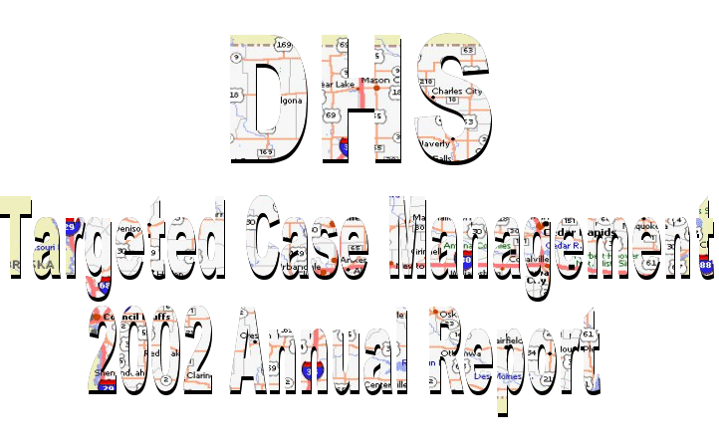

### 2002 A year to Remember

This has been a year of restructuring of the Department of Human Services, a new Director and budget woes. From a personal perspective we have entered the world of pre-authorization of service and trained over 32 new staff members in our little unit. All our Targeted case managers received new DSM 4’s and diagnosis and symptom management have taken on a new meaning in our work lives.

In Central office Dustin Karrer has lead us into an Internet database called SQL. This was and still is a bumpy ride but when data is retrieved from the system I am sure we will all think the pain was worth it. We added a quality assurance position as well as a new field SW3 and we have one reading form, a new best practice book and have assessed our progress on incremental steps, rights restrictions, and crisis plans. Our data shows we are achieving our goals at the 70% level so we need to provide additional training in these key elements. We are setting up a tracking system concerning our consumer incident reports and receive an average of 8 incidents daily.

On August 31, 2002, Grace Oemcke, our central office secretary passed away after having joined our unit 8 months prior. Grace was full of joy and we still miss her.

Central office and Des Moines staff moved to a new location. In the field we added offices in Manchester, Elkader, and Keokuk. The Marshalltown staff moved to a new location where they could be co-located with the CPC Jill Eaton.

**Hi-Lights from the last year include:**

1) Delaware County joined our operation and we are thrilled with that relationship and new staff.

2) Dubuque continued their work on the community crisis plan and added a monitoring component to their reviews as requested by their CPC Jody Jansen

3) Our Sioux City region turned over their stable leadership to two newcomers to our unit and that area is thriving

4) Consumer satisfaction increased to 91.3 %

5) The consumers involved in founded abuse situations dropped to a five -year low of .4%

6) The number of consumers involved in a work program or employment is at 36%- that is a decrease of 18% compared to last year and reflects what is happening in the economy at large.

7) We initiated a roundtable group in Jasper County to develop and implement a front-end response process to help consumers in crisis in the least restrictive manner.

The events of the last year have been a challenge and our TCM staff stood together to continue meeting customer needs in the most difficult of circumstances. The teamwork of this unit continues to be the best I have ever seen. We had some of our supervisors and field SW3’s as well as contract training staff manage cases. Both our conferences were well attended and many staff volunteered to do work that we use to pay others to do.

Like almost every American, we are looking at ways to tighten expenses while continuing to serve consumers and CPC’s and maintain our quality of service.

## Diane Diamond

Social Work Administrator, DHS Case Management

1

Advisory Board

# The Advisory Board seeks to identify areas of concern, and assist in finding solutions and ways of better serving our consumers. The following Case Management employees, county officials, and community members served on the Advisory Board for the DHS Case Management Unit in 2002.

Mary Dubert, Scott County CPC

Jill Eaton, Marshall County CPC

Ted Ely, Audubon/Greene/Guthrie County CPC

Mary Jo Greene, Palo Alto County Board of Supervisors

Dean Hargens, Crawford County Board of Supervisors

Jan Heikes, Winneshiek/Allamakee County CPC

Lori Nosekabel, Adair/Adams/Clarke/Taylor/Union County CPC

Lisa Rockhill, Lyon County CPC

Mary Williams, Benton County CPC

## Joann Hagen, Parent, Winneshiek County

Grant Reefer, Bethphage, Osceola

Chris Sparks, Exceptional Persons Inc., Waterloo

## Diane Diamond, Social Work Administrator

## Kathy Jordan, Waterloo Region Lead Supervisor

Dave Wells, Des Moines Region Lead Supervisor

Linda Conrad, Sioux City Region Supervisor

Terri Kuntz, Sioux City Region Supervisor

2

## DHS Case Management Counties Served

# Waterloo Region

C:\My Documents\Maps\Triangle.bmp

### Benton

Black Hawk

Butler

Clayton

Delaware*

Dubuque

Scott

Winneshiek

* In 2002 we were pleased to add Delaware county to the list of counties serve.

# Sioux City Region

C:\My Documents\Maps\Star.bmp

### Audubon

### Calhoun

Crawford

Greene

Guthrie

Lyon

Monona

Palo Alto

Plymouth

Pocahontas

Sioux

# Des Moines Region

C:\My Documents\Maps\DM.bmp

Clarke

### Jasper

Lee

Marion

Marshall

Warren

3

Consumer Feedback

# As we do every year, in 2002 we surveyed our consumers and their guardians. Surveys are mailed to 50% of consumers in all contracting counties, however at the request of some CPCs 100% of consumers are surveyed. The results of the total Unit survey are shown. Case Management satisfaction rating by county is also shown.

|  |  |  |  |  |
| --- | --- | --- | --- | --- |
| Question |  | Number of responses | % of total responses | % change over 2001 |
| Did some one help you complete this survey? | Yes-F | 96 | 14.6% | -8.2% |
| Yes-CM | 6 | 0.9% | -0.5% |
| Yes-E | 225 | 34.3% | 6.8% |
| Guard | 128 | 19.5% | Not asked |
| No | 190 | 29.0% | -16.9% |
| DNA | 11 | 1.7% | -0.8% |
| Do you know how to contact your case manager? | Y | 557 | 84.9% | -2.8% |
| N | 55 | 8.4% | 0.9% |
| U | 38 | 5.8% | 2.0% |
| DNA | 6 | 0.9% | -0.1% |
| Does your case manager understand what you can do and what you need? | Y | 592 | 90.2% | 0.4% |
| N | 12 | 1.8% | 0.7% |
| U | 49 | 7.5% | -0.8% |
| DNA | 3 | 0.5% | -0.3% |
| Does your case manager respect your skills and abilities? | Y | 607 | 92.5% | 2.9% |
| N | 12 | 1.8% | 0.7% |
| U | 36 | 5.5% | -2.8% |
| DNA | 1 | 0.2% | -0.8% |
| Do you decide what kinds of activities and services you want? | Y | 562 | 85.7% | -0.2% |
| N | 32 | 4.9% | -0.7% |
| U | 58 | 8.8% | 0.8% |
| DNA | 4 | 0.6% | 0.1% |

**KEY**: DNA = Did Not Answer

Y = Yes

N = No

U = Unsure/Not Sure

Yes-F = Yes a Friend or Relative

Yes-CM = Yes My Case Manager

Yes-E = Yes an employee of an agency where I receive services

Guard = Guardian completed survey

No = No I completed it myself

4

Consumer Feedback

|  |  |  |  |  |
| --- | --- | --- | --- | --- |
| Question |  | Number of responses | % of total responses | % change over 2001 |
| Did you set the goals in your case management plan? | Y | 502 | 76.5% | -1.3% |
| N | 70 | 10.7% | 1.7% |
| U | 76 | 11.6% | 0.0% |
| DNA | 8 | 1.2% | -0.4% |
| Prior to your meetings to plan your goals, do you meet with your case manager? | Y | 480 | 73.2% | -0.5% |
| N | 101 | 15.4% | 1.5% |
| U | 67 | 10.2% | -1.2% |
| DNA | 8 | 1.2% | 0.2% |
| Do you talk in your meetings? | Y | 604 | 92.1% | -2.2% |
| N | 33 | 5.0% | 2.3% |
| U | 8 | 1.2% | -0.8% |
| DNA | 11 | 1.7% | 0.7% |
| Are you satisfied with the service you receive from your case manager? | Y | 599 | 91.3% | 0.1% |
| N | 18 | 2.7% | 0.1% |
| U | 31 | 4.7% | -0.4% |
| DNA | 8 | 1.2% | 0.2% |
| Since you began work with your case manager have you felt more apart of your community? | Y | 548 | 83.5% | 3.5% |
| N | 30 | 4.6% | -1.4% |
| U | 62 | 9.5% | -1.8% |
| DNA | 16 | 2.4% | -0.3% |

**KEY**: DNA = Did Not Answer

Y = Yes

N = No

U = Unsure/Not Sure

Yes-F = Yes a Friend or Relative

Yes-CM = Yes My Case Manager

Yes-E = Yes an employee of an agency where I receive services

Guard = Guardian completed survey

No = No I completed it myself

5

Consumer Feedback

## The percentage of satisfied consumers is shown by county

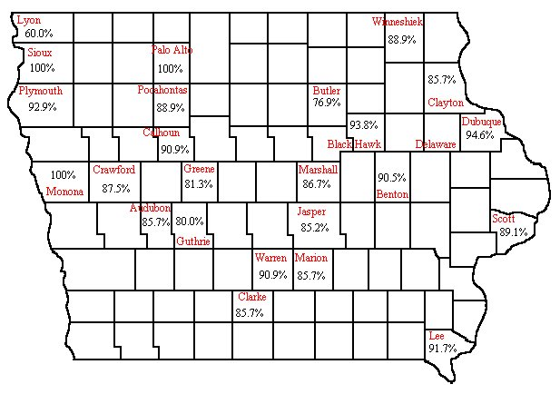

* DHS Case Management did not serve Delaware County in 2002.

6

*

Consumer Feedback - Comments

|  |
| --- |
| In addition to numerical data, the consumer we survey each year and their guardians provide us with valuable comments regarding our service. A few comments are listed below by county. |
| “(Case Manager) is very helpful and always available when needed.” |
| (Case Manager) is professional and kind. We appreciate her. |
| “I think that (Case Manager) is the best case manager I have ever had. She is supporting, we talk things through and between her, (Social Worker) and I we get things done.” |
| “We are very pleased with our case manager. Not only does she do her job, she is very happy, and enjoys her job and it shows in how she trusts people.” |
| “(Case Manager) does a wonderful job advocating for the person I’m guardian for. She ensures he receives appropriate care and I think genuinely cares about him as a person. I commend her for her hard work.” |
| “(Case Manager) does a great job.” |
| “I am very satisfied with my case manager.” |
| “As guardians of (Consumer) we are very satisfied with her case manager. She is always pleasant and patient with us. We appreciate her keen insight and wisdom concerning her daughter.” |
| “Our case manager is so great. We all love her. She does a fantastic job with (Consumer) and she is easy to understand.” |
| “(Case Manager) is very helpful and easy to work with.” |
| “(Case Manager) is professional, caring, and extremely helpful. She is wonderful.” |
| “(Case Manager) does a great job. I have no complaints.” |
| “We are very please with our Case Manager.” |
| “(Case Manager) is the best case manager I have ever worked with.” |
| “(Case Manager) is doing a great job for our family and me. We see him as often as possible and talk to him on the phone on a regular basis.” |
| “(Case Manager) does a great job and does not need to do her job better.” |
| “(Case Manager) is very helpful and very nice, I like her.” |
| “I would like to take this opportunity to say that our case manager is outstanding in every way.” |
| “We feel fortunate that he is our case manager.” |
| “(Case Manager) does an excellent job of advocating for (Consumer).” |

7

CPC Feedback

|  |  |  |  |  |  |
| --- | --- | --- | --- | --- | --- |
| **Audubon\*** | **Benton** | **Black Hawk** | **Butler** | **Calhoun\*\*** | **Clarke** |
| Targeted Case Management is flexible. They work with folks on an individual basis, are efficient, and conservative financially. | CM has a monthly meeting with CPC. They play a big roll letting the county know what services would be helpful and what ones are not. | (TCM is) on top of changes in the field as best as could be expected. They bring expertise to the job. No complaints from any consumers. | Specifically the two case managers I have worked with for the past several years are exceptional. They have my complete confidence in making professional decisions and with client service. | This service keeps the county informed regarding services to consumers. It is cost effective to the counties at this time. | DHS TCM participates in provider meetings and stakeholders meetings. This is very helpful when Case Manager participates. |
| **Clayton** | **Crawford** | **Dubuque** | **Greene\*** | **Guthrie\*** | **Jasper** |
| TCM has knowledge of the System. Case Managers have resources. They know the rules, or who to check with. | The case managers are actively involved in developing new services. Using DHS TCM facilitates the development of services. | TCM has competent staff, lots of training and compassionate people. | Targeted Case Management is flexible. They work with folks on an individual basis, are efficient, and conservative financially. | Targeted Case Management is flexible. They work with folks on an individual basis, are efficient, and conservative financially. | We have really good case managers in Jasper County. |
| **Lee** | **Lyon** | **Marion** | **Marshall** | **Monona** | **Palo Alto** |
| Five year track record of excellent services. | The case managers do a good job of identifying needs in consumers. | Excellent case managers who are available to the CPC when they are needed. | The continuous contact with the client is helpful to learn the actual needs. | Good working relationship with supervisor and case manager. Seems to be experienced and knowledgeable | DHS TCM does a great job of monitoring and coordination of all services. It costs the county less to have case management services provided by DHS. |
| **Plymouth** | **Pocahontas\*\*** | **Scott** | **Sioux** | **Warren** | **Winneshiek** |
| (The CPC) feels the case management unit is courteous and professional with clients and providers. | This service keeps the county informed regarding services to consumers. It is cost effective to the counties at this time. | TCM takes cases quickly, provides great clinical judgment, and respect of the CPC office. | The DHS Case Managers are professional, well trained, and have good interactions with the consumers and their family members, providers, and other people in the community. | The case managers are very proactive. It is good to have an advocate for the consumers. The Board has complemented TCM on their presentations. | Case Managers do a great job. Case Management has a statewide pool to draw from. |

# * Audubon, Guthrie, and Green Counties have the same CPC. Pocahontas and Calhoun Counties have the same CPC.

8

Technology Update

# In previous years data collection for the annual report was handled through a database of information maintained by Iowa State University. When an assessment was created for a consumer the case manager would send a copy to ISU and it would be keyed into the database. The information from the assessment could then be used to generate the data we use to evaluate the safety, health, self-sufficiency, and stability of our consumers. While this process provided accurate and reliable data it was not efficient. Data had to be entered twice, once by the case manager on to the assessment and again by ISU staff into the database.

In an effort to improve efficiency of data collection, and to insure a method for tracking consumer information that would provide flexibility as technology improved a new system was developed. This system allows the information entered by the case manager on the assessment, and other documents to be placed directly into the database, eliminating the need for duplicate entry.

The forms used by case managers have not changed; they have simply been moved from Microsoft Word to a web site that allows information entered to be stored in, and viewed from a database rather than a Word document. With this information going directly into the database we are able to provide accurate and up to date reports at any time.

The technology we are using is called SQL or Structured Query Language and since it is connected to a web site, changes and updates to Microsoft Word will not effect it. The data used to produce the 2002 Case Management Annual Report all comes from our new SQL database.

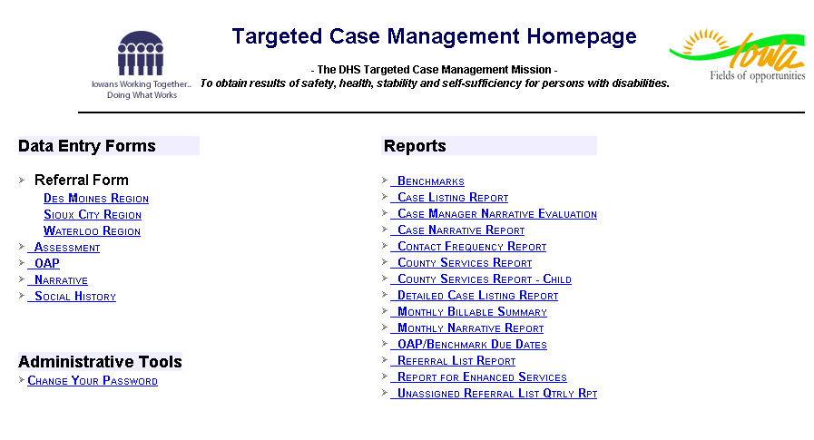

9

Assessment Data

Assessment data has been collected for all consumers since the assessment project began in 1997. The information in this annual report looks back five years to compare assessment information from 1998 through 2002. The information is based on annual assessments of all adult consumers of the Targeted Case Management Unit. We reviewed data related to consumer’s health, safety, self-sufficiency, and stability. Data for the 2002 annual report comes from our newly implemented SQL database that replaces the database previously maintained by Iowa State University.

**Safe Consumers-** Less than one half of one percent of our consumers reported founded abuse

**Healthy Consumers-**  Only 1.3% of consumers had a 23-hour observation in 2002.

**Self Sufficient Consumers-** The mean income for consumers in competitive employment rose over $50.00 in 2002.

**Stable Consumers-** The Majority of our consumers continue to live in their own home or with a relative.

10

Assessment Data - Safe Consumers

# ABUSE REPORTS AND CRIMINAL CONVICTIONS

Founded abuse reports are counted only when the consumer is the victim of the abuse. They are reported below by primary diagnosis as a percent of the total population for that year.

|  |  |  |  |  |
| --- | --- | --- | --- | --- |
| Year | **MR** | **CMI** | **DD** | **Percent of total assessment population** |
| **1998** | 0.75% | 0.75% | 0.0% | **0.7%** |
| **1999** | 0.5% | 1.4% | 1.5% | **0.8%** |
| **2000** | 0.5% | 1.1% | 0.6% | **0.7%** |
| **2001** | 0.2% | 1.2% | 0.5% | **0.5%** |
| **2002** | 0.4% | 0.7% | 0.0% | **0.4%** |

Criminal convictions - only those with a legal judgment are tallied for Case Management consumers and are counted during the year that the legal judgement occurred.

|  |  |  |  |  |
| --- | --- | --- | --- | --- |
| Year | **MR** | **CMI** | **DD** | **Percent of total assessment population** |
| **1998** | 1.0% | 3.1% | 2.9% | **1.7%** |
| **1999** | 0.5% | 3.7% | 2.6% | **1.5%** |
| **2000** | 0.8% | 2.7% | 3.0% | **1.6%** |
| **2001** | 1.7% | 1.9% | 1.7% | **1.8%** |
| **2002** | 0.8% | 2.0% | 2.2% | **1.2%** |

11

Assessment Data - Healthy Consumers

The percentage of consumers who had medical hospitalizations is shown by diagnosis and as a percent of the total population.

|  |  |  |  |  |
| --- | --- | --- | --- | --- |
| Year | **MR** | **CMI** | **DD** | **Percent of total assessment population** |
| **1998** | 5.2% | 12.4% | 13.5% | **7.7%** |
| **1999** | 5.4% | 13.4% | 7.7% | **7.4%** |
| **2000** | 5.5% | 11.1% | 15.7% | **8.0%** |
| **2001** | 6.0% | 10.3% | 11.5% | **7.8%** |
| **2002** | 7.8% | 11.45% | 8.0% | **8.6%** |

The percentage of 23-hour observations is shown by diagnosis and as a percent of the total population

|  |  |  |  |  |
| --- | --- | --- | --- | --- |
| Year | **MR** | **CMI** | **DD** | **Percent of total assessment population** |
| **1998** | 1.0% | 5.0% | 1.75% | **2.0%** |
| **1999** | 1.0% | 5.3% | 1.0% | **2.0%** |
| **2000** | 1.0% | 4.9% | 0.6% | **2.0%** |
| **2001** | 1.2% | 2.2% | 0.0% | **1.4%** |
| **2002** | 0.7% | 2.1% | 0.7% | **1.3%** |

Percentage of psychiatric hospitalizations is show by diagnosis and as a percent of the total population.

|  |  |  |  |  |
| --- | --- | --- | --- | --- |
| Year | **MR** | **CMI** | DD | **Percent of total assessment population** |
| **1998** | 3.0% | 28.0% | 3.0% | **9.3%** |
| **1999** | 3.8% | 33.2% | 4.6% | **11.5%** |
| **2000** | 4.0% | 26.6% | 3.0% | **7.2%** |
| **2001** | 4.0% | 27.0% | 4.6% | **11.2%** |
| **2002** | 4.0% | 26.7% | 2.9% | **10.9%** |

12

Assessment Data – Self Sufficient Consumers

# WORK SETTINGS BY PRIMARY DIAGNOSIS 2002

|  |  |  |  |
| --- | --- | --- | --- |
| Work Setting | **MR** | **CMI** | **DD** |
| Competitive | 147 | 100 | 28 |
| Supported | 140 | 46 | 16 |
| Sheltered Work | 383 | 108 | 17 |

# TOTAL PERCENTAGE OF CONSUMERS IN A WORK SETTING 2002

|  |  |
| --- | --- |
| **Work Setting** | **Percentage** |
| Competitive | 10.1% |
| Supported | 7.4% |
| Sheltered Work | 18.6% |
| All Combined | 36.1% |

# AVERAGE MONTHLY EARNED INCOME

|  |  |  |  |  |  |
| --- | --- | --- | --- | --- | --- |
|  | **1998** | **1999** | **2000** | **2001** | **2002** |
| Competitive | $307.12 | $401.31 | $368.67 | $369.28 | $429.29 |
| Supported | $288.51 | $303.45 | $327.05 | $317.56 | $280.07 |
| Sheltered Work | $142.31 | $136.02 | $162.88 | $135.46 | $171.13 |

13

Assessment Data – Stable Consumers

**LIVING SITUATIONS BY PRIMARY DIAGNOSIS**

Consumers who live in their own home or a relatives home score significantly higher on the assessment. This demonstrates the positive impact the home setting has on other result areas. As you can see a majority of our consumers live in their own home or with a relative.

|  |  |  |  |
| --- | --- | --- | --- |
| **2002** | **MR** | **CMI** | **DD** |
| Own home | 868 | 477 | 72 |
| Relative’s home | 398 | 51 | 39 |
| RCF | 115 | 242 | 15 |
| RCF-MR | 143 | 4 | 8 |
| RCF-MI | 1 | 25 | 0 |
| ICF | 10 | 3 | 1 |
| ICF/MR | 2 | 1 | 0 |
| Family Life Home | 0 | 0 | 0 |
| Skilled Nursing Facility | 0 | 0 | 0 |
| Jail | 0 | 1 | 0 |
| Other | 44 | 61 | 3 |

14

Assessment Data – Assessment Score Summary

16

*For a detailed explanation of each assessment area please see the appendix.

2002 FINANCIAL INFORMATION

The DHS Targeted Case Management Unit operates as a Medicaid provider. The unit operates on a projected rate for reimbursement of services and then retrospectively settles with various funders on actual costs incurred.

The Federal share in SFY 2002 was 62.81%. The State of Iowa and the counties with which we contract split the remainder of costs, or 18.595% each. The unit does not receive an appropriation and operates solely upon revenues generated for services provided. The basis for allowable reimbursable costs is only those costs directly associated with providing TCM.

## The unit's salary costs represent 84% of total expenses and is limited to staff who meet directly with the consumers and staff assisting those who meet with consumers. Support costs include items such as rent, travel, training, technology, office equipment, and telephones.

* Numbers of units of service provided were 35,881 compared to 32,169 the previous year. This was an 11.5% increase over the prior year and was due in part to the Adult Rehabilitation Option (ARO) and the waiver programs. Due to this trend and the state of the economy:
* 100% County funded TCM services decreased by 22 % from the previous year
* 100% Private funded TCM services decreased by 85% from the previous year
* The DHS TCM financial team consists of two financial professionals performing the functions of Accountant and Budget Analyst; complemented by four full time field account technicians. The Financial Audit Division of the Auditor of State performed a full financial audit for SFY 2002.

17

